**FRESH FIELDS**

**A Project Report**

***Submitted by***

**RIYA ADSUL**

**RISHABH TULSHYAN**

**AARYAN SARNAIK**

**DEVIKA SURYAWANSHI**

**SOUMIL SHINDE**

***Under the Guidance of***

**Prof. Ameyaa Biwalkar**

***in partial fulfillment for the award of the degree of***

**BTECH**

**COMPUTER ENGINEERING**

At



**MUKESH PATEL SCHOOL OF TECHNOLOGY, MANAGEMENT AND ENGINEERING, MUMBAI**

**APRIL, 2020**

**DECLARATION**

I, Aaryan Sarnaik, Devika Suryawanshi, Rishabh Tulshyan , Riya Adsul and Soumil Shinde, Roll No. B044,B073,B074,B100,B101 BTech (Computer Engineering), IV semester understand that plagiarism is defined as anyone or combination of the following:

1. Un-credited verbatim copying of individual sentences, paragraphs or illustration (such as graphs, diagrams, etc.) from any source, published or unpublished, including the internet.
2. Un-credited improper paraphrasing of pages paragraphs (changing a few words phrases, or rearranging the original sentence order)
3. Credited verbatim copying of a major portion of a paper (or thesis chapter) without clear delineation of who did wrote what. ( Source: IEEE, The institute, Dec. 2004)
4. I have made sure that all the ideas, expressions, graphs, diagrams, etc., that are not a result of my work, are properly credited. Long phrases or sentences that had to be used verbatim from published literature have been clearly identified using quotation marks.
5. I affirm that no portion of my work can be considered as plagiarism and I take full responsibility if such a complaint occurs. I understand fully well that the guide of the seminar/ project report may not be in a position to check for the possibility of such incidences of plagiarism in this body of work.

Signature of the Students: __________, _____________, ____________, ______________

Names Aaryan Sarnaik, Devika Suryawanshi, Rishabh Tulshyan , Riya Adsul, Soumil Shinde

Roll Nos. : B044,B073,B074,B100,B101

Place: Mumbai

Date: 06/04/2021

**CERTIFICATE**

This is to certify that the project entitled “FRESH FIELDS” is the bonafide work carried out by Aaryan Sarnaik, Devika Suryawanshi, Rishabh Tulshyan , Riya Adsul and Soumil Shinde of BTECH Tech, MPSTME (NMIMS), Mumbai, during the IV semester of the academic year 2020-2021, in partial fulfillment of the requirements for the Course Programming Language.

___________________

Prof. Ameyaa Biwalkar

Internal Mentor

_______________________ ________________________

Examiner 1 Examiner 2

**Table of contents**

**CHAPTER NO. TITLE PAGE NO.**

1. INTRODUCTION
2. SOFTWARES AND API USED WITH DESCRIPTION
3. METHODS IMPLEMENTED
4. SCREENSHOTS
5. CONCLUSION & FUTURE SCOPE
6. SOCIETAL APPLICATION

**INTRODUCTION**

In today’s world, or any item to reach from the farmer to the consumer involves a lot of steps and middlemen which can cause the process to slow down and also cause hoarding of prices where only the farmer and consumer are at a loss.

Hoarding of the agricultural production leads to a hike in the price of the crop/end product. Hence, there is a need for a platform that will help the authorities keep a track of the trade, and take down any such hoarding practices being performed at any stage.

Our Idea was to create such a platform for the farmers connecting them directly to the consumers and workers thus expanding their business. This platform will allow these stakeholders to interact with each other and will facilitate the hiring of labor and purchase and sale of raw materials and produce respectively. Fresh Fields enables farmers to sell their products online. We provide technology and services to the farmers, merchants, and farm laborers, thus providing them with a wider great experience with an easy-to-use application.

Farmers can sell their produce online which can be purchased by wholesalers and retailers, and can also purchase farming products.

• There are three types of users: farmers, wholesalers/retailers/consumer and workers. The login ID and password is required to login to the system.

• The articles and statistics sections help farmers to gain knowledge.

• It has a history section which help the farmers keep a track of their uploaded produce and the customer to view the produce he/she has bought.

• It also helps the farm laborer’s in finding jobs.

The scope of this application currently includes all the cities and districts present in the state of Maharashtra

**SOFTWARES AND MODULES USED**

**SOFTWARE REQUIREMENTS**

* Operating system – **Windows 10** is used as the operating system as it is

stable and supports more features and is more user friendly.

* Database Management System – **DB Browser for SQLite** (DB4S) is a high quality, visual, open-source tool to create, design, and edit database files compatible with SQLite.
* English language. The queries are easy to understand and to write.
* Development tools and Programming language **– Python** is used to write

the whole code and **Python Tkinter** is used for designing and styling of

front end.

**TOOLS AND LIBRARIES USED**

**TOOLS**

* PyCharm IDE is used for writing the code and developing the system.
* **DB Browser for SQLite** Libraries
* **Canva-** Used to edit images used in the background and on buttons

**LIBRARIES**

The following python libraries have been used:

* **tkinter** – Tkinter is the standard GUI (Graphic User Interface) library for

Python. Tkinter provides a fast and easy way to create GUI applications.

* **PIL(Image, ImageTk):** Python Imaging Library is a free and open-source additional library for the Python programming language that adds support for opening, manipulating, and saving many different image file formats.

* **Pandas** (DataFrame) :

**pandas** is a fast, powerful, flexible and easy to use open source data analysis and manipulation tool, built on top of the **Python** programming language.

* **Matplotlib:** It is a comprehensive library for creating static, animated, and interactive visualizations in **Python**

* **SQLite 3** : SQLite is a relational database management system contained in a C library. In contrast to many other database management systems, SQLite is not a client–server database engine**.**

**METHODS IMPLEMENTED**

1. **def statistics ():**

This method displays 7 different types of statistics that are dynamically changed according to the data present in the application database which has all the information related to the purchasing of products, uploading of produce, and hiring of workers that users carry out using the application.

1. **def demand_products ():**

This function displays a bar chart showing the number of unique customers who have purchased a particular produce from the dashboard, the x axis has the produce name whereas the y axis has the number of unique customers.

1. **def supply_products ():**

This function displays a bar chart showing the number of unique farmers who have uploaded a particular produce on the dashboard, the x axis has the produce name whereas the y axis has the number unique farmers.

1. **def VvsP_Purchased ():**

In this function we are first provided with a dropdown menu having all the produce that has been sold from our inventory (this is stored in the customer_history table), after we select the type of produce, we want, a pie chart is displayed having the distribution of various varieties of that particular produce that has been purchased by the customers.

1. **def VvsP_Inventory ():**

In this function we are first provided with a dropdown menu having all the produce that is currently available in our inventory (uploaded by the farmers), after we select the type of produce, we want, a pie chart is displayed having the distribution of various varieties of that particular produce that are available in our inventory .

1. **def districtVSfarmer ():**

This function displays the top 10 districts in Maharashtra with the greatest number of registered farmers

1. **def districtVSworker ():**

This function displays the top 10 districts in Maharashtra with the greatest number of registered workers

1. **def CustomerTypeDistribution ():**

This function displayed a pie chart with the distribution of customer type (wholesaler, retailer, consumer) of the registered customers (the customer inputs this information during the registration process)

1. **def welcome_page():**

This function displays the first welcoming page of the dashboard. There are two buttons, one connected to the statistics dashboard and the other connected to the main application dashboard.

1. **def main_page():**

This page has 3 frames: customer, farmer and worker, each containing 2 buttons: login and register connected the user to the login page or register page of the customer, farmer or worker.

1. **def article():**

This function is used to display articles uploaded by the admin to all three dashboards, customer farmer and worker.

The user first has to select an article name from the dropdown after which that article (stored in the database) is displayed to the user along with its title and date of publishing.

1. **customer_register():**

Creates the GUI of the customer register using Tkinter. Has multiple methods to add functionality and error handling to the page. It also has the required logic in it to make sure that the district and city buttons are bound to each other. It prompts the user to enter the following data by the means of various input widgets in tkinter, which is later stored in the database by means of sqlite3 : Name, Contact Number, Email Id, Password, District, City, Pincode, Customer Type, Address.

1. **register():**

This method is bound to the register button. It inserts all the data inputted by the user into the database using sqlite3.

1. **delete_data(entry_field):**

Takes an entry field as a parameter and empties its contents.

1. **is_number(entry_field):**

Takes an entry field as a parameter and checks if its content is an integer and if it is not, returns a ValueError.

1. **customer_district():**

Gets the district selected by the user from the district list and dynamically appends the respective cities to the city dropdown.

**F. farmer_register():**

Creates the GUI of the farmer register using Tkinter. Has multiple methods to add functionality and error handling to the page. It also has the required logic in it to make sure that the district and city buttons are bound to each other. It prompts the user to enter the following data by the means of various input widgets in tkinter, which is later stored in the database by means of sqlite3 : Name, Contact Number, Email Id, Password, District, City, IFSC Code, Account Number, Address.

1. **register():**

This method is bound to the register button. It inserts all the data inputted by the user into the database using sqlite3.

1. **delete_data(entry_field):**

Takes an entry field as a parameter and empties its contents.

1. **is_number(entry_field):**

Takes an entry field as a parameter and checks if its content is an integer and if it is not, returns a ValueError.

1. **farmer_district():**

Gets the district selected by the user from the district list and dynamically appends the respective cities to the city dropdown.

**G. worker_register():**

Creates the GUI of the worker register using Tkinter. Has multiple methods to add functionality and error handling to the page. It also has the required logic in it to make sure that the district and city buttons are bound to each other. It prompts the user to enter the following data by the means of various input widgets in tkinter, which is later stored in the database by means of sqlite3 : Name, Contact Number, Email Id, Password, District, City, Expected Salary, Worker Status, Address, Work Profile.

1. **register():**

This method is bound to the register button. It inserts all the data inputted by the user into the database using sqlite3.

1. **delete_data(entry_field):**

Takes an entry field as a parameter and empties its contents.

1. **is_number(entry_field):**

Takes an entry field as a parameter and checks if its content is an integer and if it is not, returns a ValueError.

1. **farmer_district():**

Gets the district selected by the user from the district list and dynamically appends the respective cities to the city dropdown.

**H. customer_login():**

Creates the GUI for the customer login page. Prompts the user to enter the Email and Password for his/her account and then checks if the user entered is present in the database.

**login_verify_customer(username1, password1):**

This method is bound to the login button and gets the user-entered username(email) and password as parameters. If the fields are empty, then the respective error is shown. It then checks if the respective email and password is present in the sql database. If it isn’t, it returns an error and allows the user to re-enter the details, and if it is the user is redirected to the customer dashboard.

**I. farmer_login():**

Creates the GUI for the farmer login page. Prompts the user to enter the Email and Password for his/her account and then checks if the user entered is present in the database.

**login_verify_farmer(username1, password1):**

This method is bound to the login button and gets the user-entered username(email) and password as parameters. If the fields are empty, then the respective error is shown. It then checks if the respective email and password is present in the sql database. If it isn’t, it returns an error and allows the user to re-enter the details, and if it is the user is redirected to the farmer dashboard.

**J. worker_login():**

Creates the GUI for the worker login page. Prompts the user to enter the Email and Password for his/her account and then checks if the user entered is present in the database.

**login_verify_worker(username1, password1):**

This method is bound to the login button and gets the user-entered username(email) and password as parameters. If the fields are empty, then the respective error is shown. It then checks if the respective email and password is present in the sql database. If it isn’t, it returns an error and allows the user to re-enter the details, and if it is the user is redirected to the worker dashboard.

**K. def worker_dashboard(wlogin, username,article,welcome):**

This function is used to display the GUI having all the functionalities used by a worker after he logs in to the application.There are 3 buttons in the window each pointing to a different function.

Arguments : wlogin – to destroy the login window

Username – to enter information inputted by the farmer in the database using  email as the primary key

Article: to display the article window to the worker in his dashboard

Welcome : to go back to the welcome page

* 1. **def bio():**

This function is used to save/alter the bio data entered by the worker in the worker table using the reference of his email.

* 1. **def status():**

This function is used to display the status of a particular worker.When a farmer hires the worker, the farmers name and contact number is displayed to the worker along with a hired message(this is stored in the farmer_worker table),

If he is not hired, then a message saying not hired yet appears 

* 1. **def logout():**

This function is used to log out of the worker dashboard and go to the welcome page.

**L. def farmer_dashboard(flogin,username,article,welcome) :**

This is the UI which is displayed when the farmer login is successful. There are 8 buttons on the dashboard each pointing to a different function

Arguments : flogin – to destroy the login window

Username – to enter information inputted by the farmer in the database using  email as the primary key

Article: to display the article window to the farmer in his dashboard

Welcome : to go back to the welcome page

1. **def produce_for_sale():**

In this method, the farmers can check their products currently present with us in our inventory, the crops names are displayed using treeview function along with the quantity left

1. **def hired_workers():**

here the farmers can check the details of the worker they have hired through our application. They get the name, contact number, email and job profile of the workers.

1. **def farmer_upload():**

In this function the farmer uploads his crops in our application, they choose the category of the crop from a dropdown which is bound to the produce drop down menu, which is bound with the variety drop down. When the farmer chooses all the they enter the quantity and price per unit quantity of that crop, whose entry also handles the exception handling. When the crop is successfully inserted we get a message box displaying the success.

1. **def farmer_hire():**

In this method the farmer can view all the workers present(registered) in his chosen city district from the dropdown menu. A tree view table of workers where the workers name, contact number, profile, expected salary and email is displayed. Farmers can choose the worker and click the hire button.

1. **def farmer_kit():**

In this the farmers can buy various products for their fields. They have to choose the category of the product first, then select the product he wants to buy. After this he can enter the quantity of the product he wants and the quantity type is displayed beside the product name along with the price per unit quantity. Then click the add to cart button which will add the item with the quantity to the cart

1. **def farmer_cart():**

Here, the farmer can view the items he has inserted into the cart. It displays the total cost of each item by multiplying the quantity with the price per unit quantity. It also displays the total amount of the cart. It gives the farmer to buy the items in it. After successfully buying the cart gets cleared.

**M. def customer_dashboard(clogin,username,article,welcome) :**

This is the UI which is displayed when the customer login is successful. There are 5 buttons on the dashboard each pointing to a different function

Arguments : clogin – to destroy the login window

Username – to enter information inputted by the customer in the database using email as the primary key

Article: to display the article window to the customer in his dashboard

Welcome: to go back to the welcome page

1. **def cust_buy():**

In this method, the customer is redirected to the window where he can have a look at the available products to buy which are uploaded by the farmer. He can choose the category of the crop from a dropdown which is bound to the produce drop down menu, which is bound with the variety drop down. A treeview of all the products with his/her chosen specifications are displayed with their respective prices. He can also add the required quantity of the chosen product to cart from this window.

1. **def customer_cart():**

Here, the customer can view his cart which shows the details of all the items he has added to it and the total price he has to pay to book these items. There is also a buy now button which allows the farmer to buy the product and clear the cart, adding the bought products to the history.

1. **def customer_history():**

This method redirects the user to a window where he can see all the products he has bought in the past.(uses customer_history table)

1. **def logout():**

This method redirects the customer back to the welcome page and logs him out of his account.

**SCREENSHOTS WITH EXPLANATIONS**

WELCOME PAGE

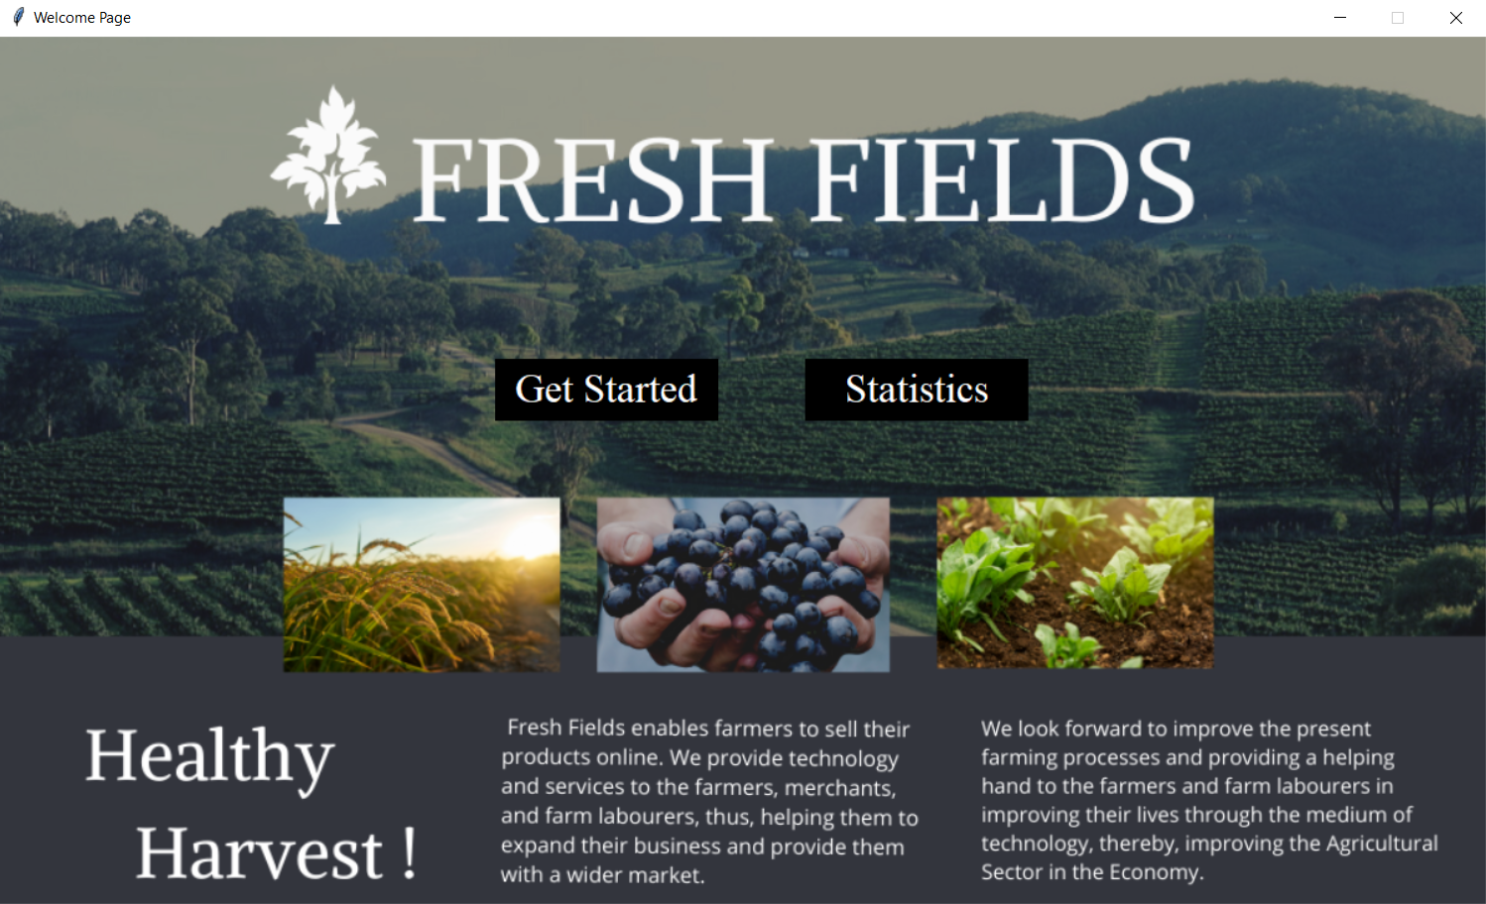

Our welcome page consists of two buttons 1. Get Started and 2. Statistics. Get Started button will open the main page where the Farmer, consumer and Worker will Login & registration. The Statistics button will open the statistics dashboard where all the statistics are displayed.

STASTICS PAGE

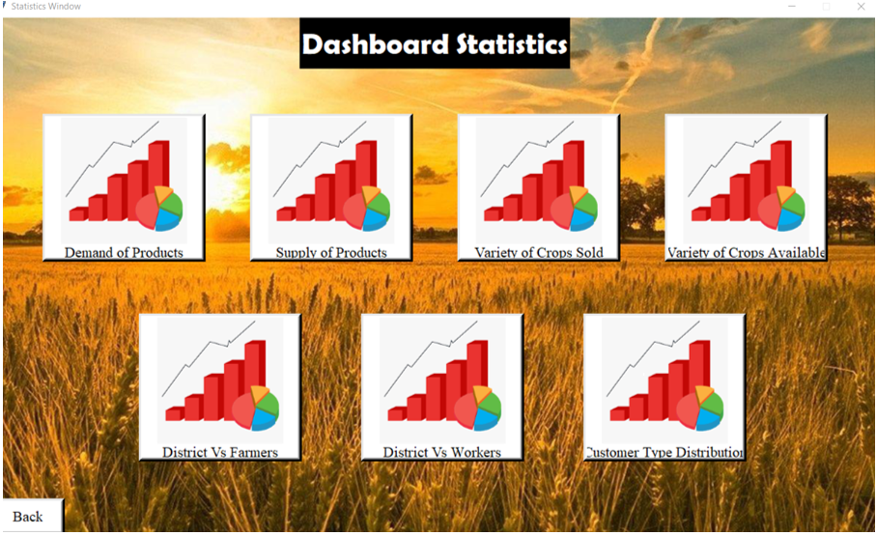

This is static dashboard page where all statistic (bar graph, pie charts) are displayed

-Demand of products

-supply of products

-variety of crops sold

-variety of crops Available

-District vs Farmer

--district vs worker

-customer type distribution

DEMAND OF PRODUCTS BAR GRAPH

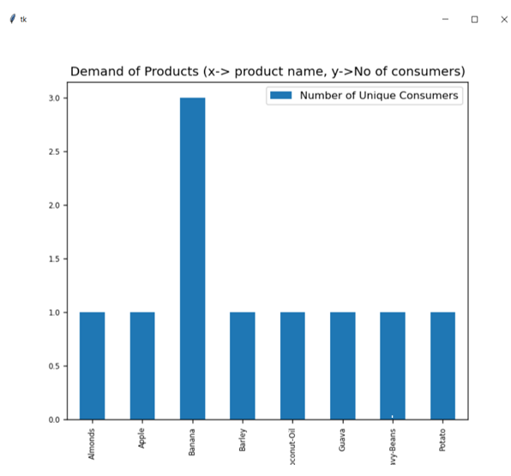

SUPPLY OF PRODUCTS BAR GRAPH

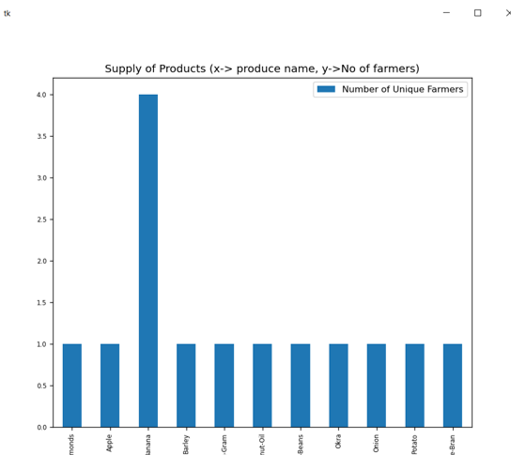

PIE CHART FOR VARIETY OF CROPS AVAILABLE

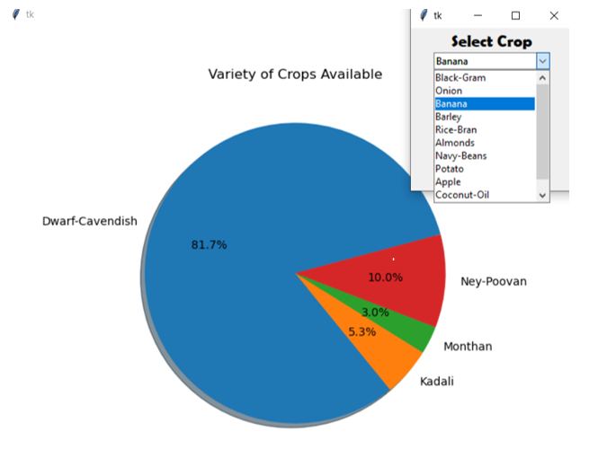

PIE CHART FOR VARIETY OF CROPS SOLD

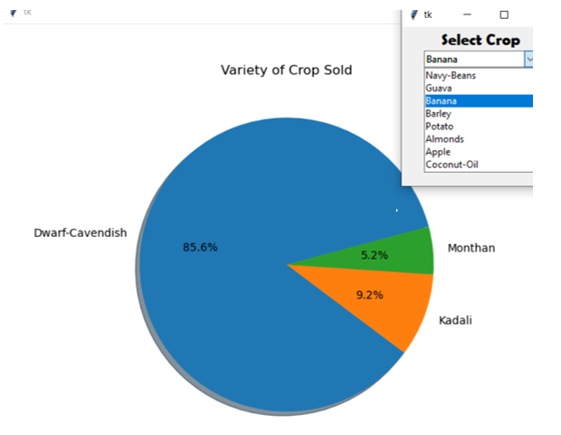

DISTRICT WISE DISTRIBUTION OF FARMER BAR GRAPH

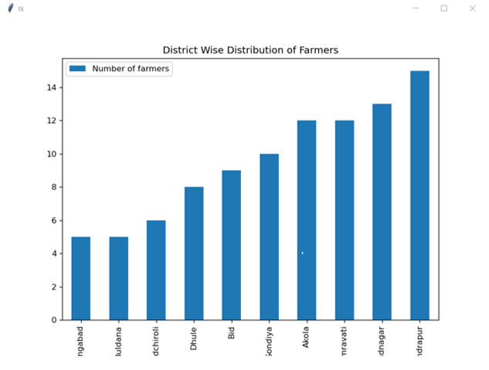

DISTRICT WISE DISTRIBUTION OF WORKERS

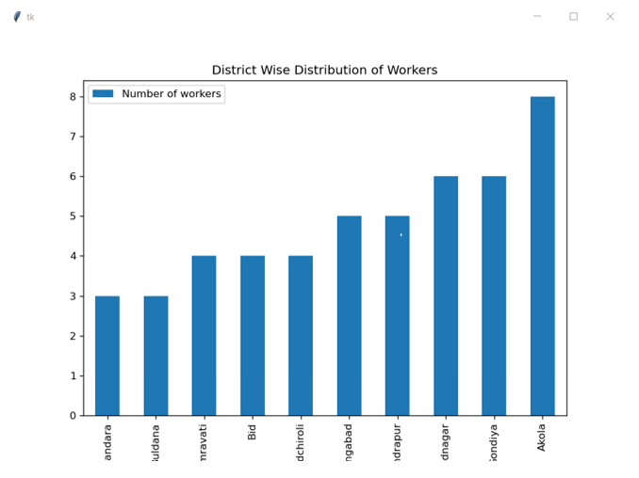

CUSTOMER TYPE DISTRIBUTION PIE CHART

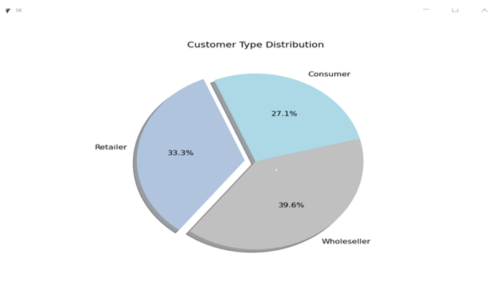

MAIN LOGIN & REGISTRATION PAGE

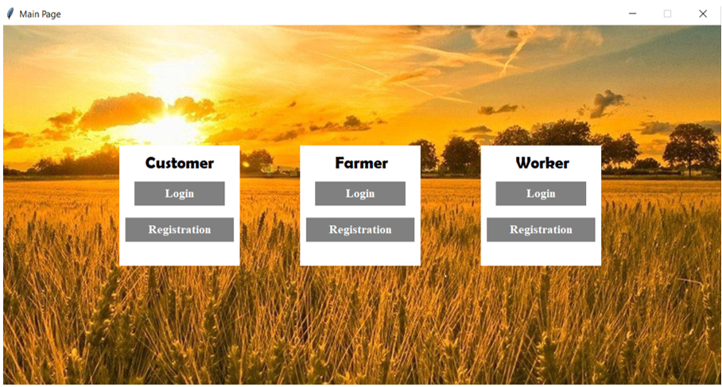

This is the main login and registration page where customer farmer and workers can login.

REGISTRATION PAGE

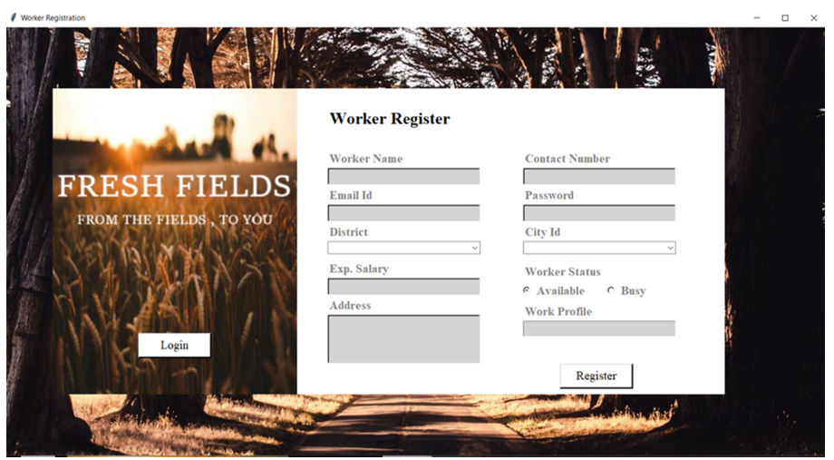

This is the registration page where the new workers, farmers and customer can register themselves.

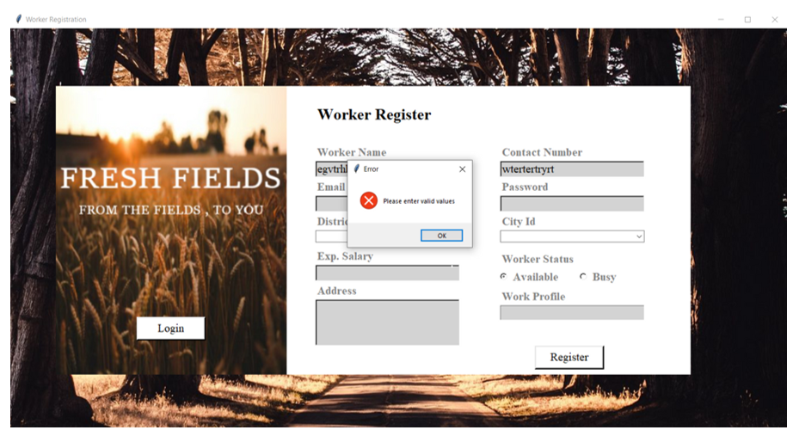

It will show an error if invalid values are entered.

LOGIN PAGE

This is the Login system page only when correct details are entered the user will be able to login else it will show error.

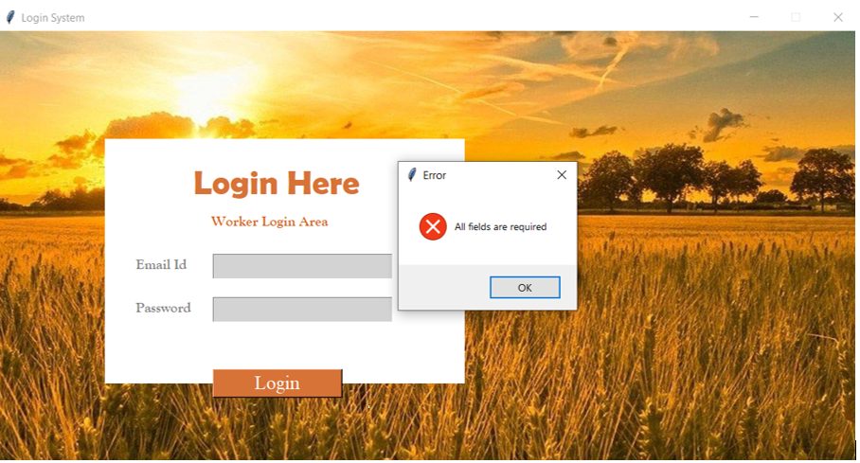

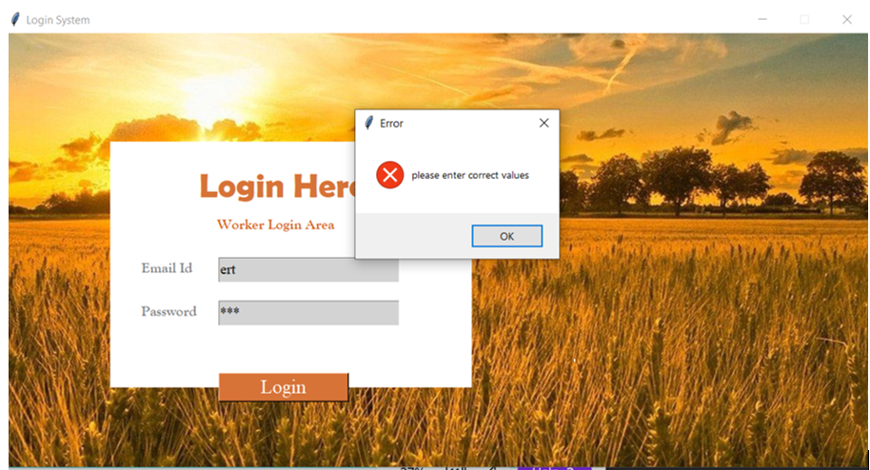

FARMER DASHBOARD

The Farmer dashboard has article button where the articles will be displayed.

Market button the farmer will be able to add the available crops or vegetables by choosing their category , produce and variety type from the dropdowns and enter their price and quantity.

The kit button, farmers will be able to purchase farm products from here.

Cart button, the products which the farmer wants to purchase will be added here and the final bill amount will be displayed.

Hire button the farmers can hire the workers

My crops will display all the crops available in the inventory.

Hired worker will display all the workers hired by the farmer.

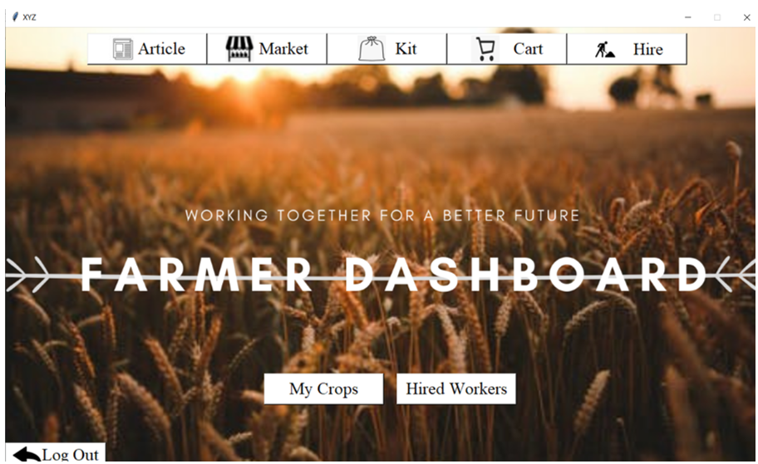

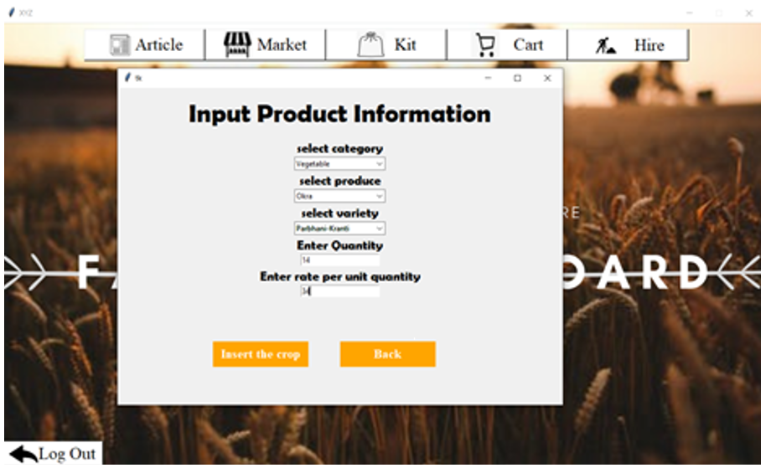

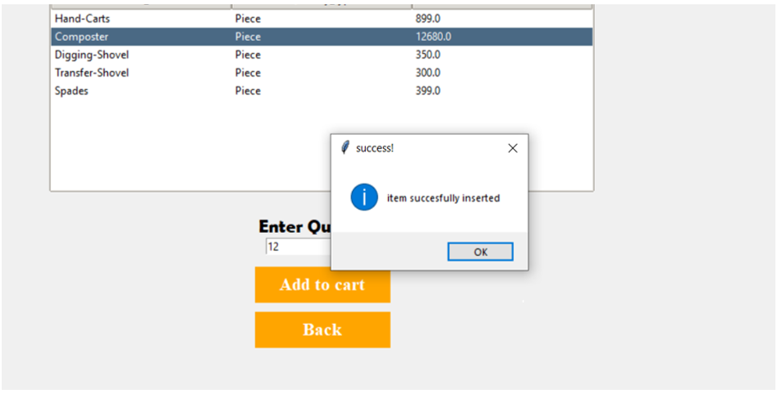

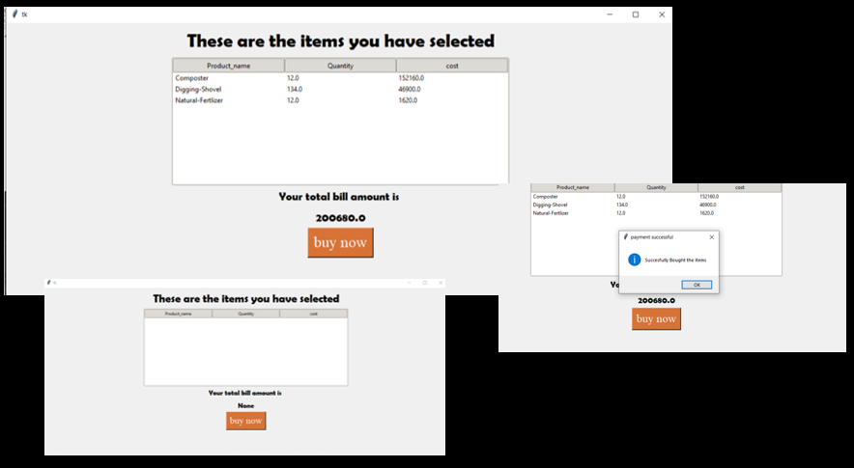

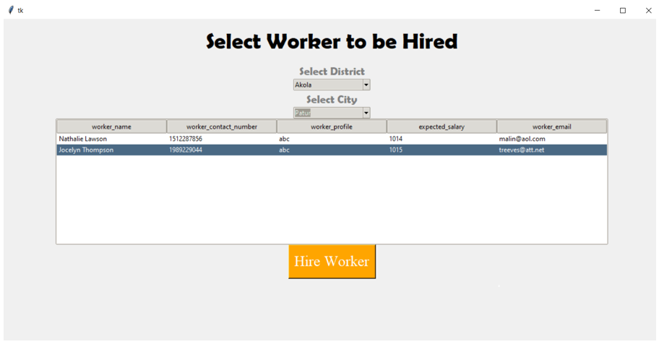

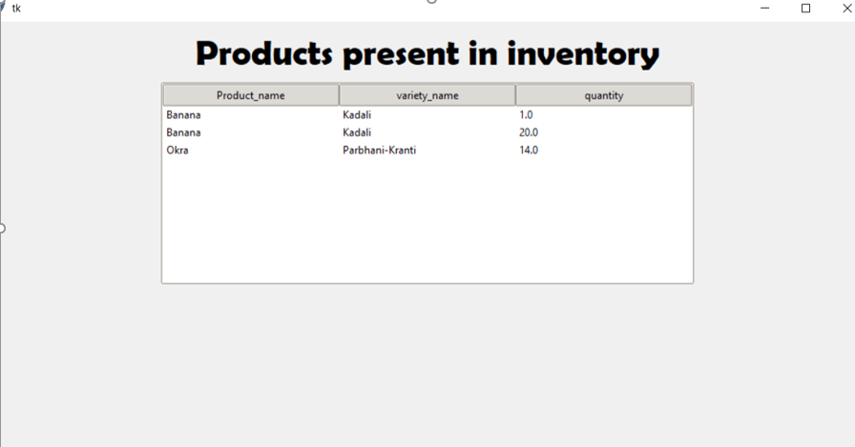

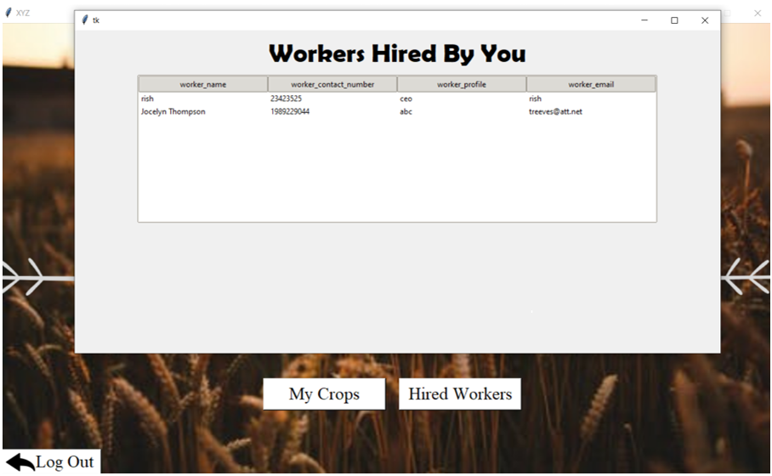

CUSTOMER DASHBOARD

The customer will be able to read the articles.

Market button the customer will be able to purchase the products uploaded by farmers that are present in our inventory, the customer will select his specifications and all products matching that will be displayed along with their price , the customer can then choose a product that he likes and ad it to the cart

Cart button all the products will be added to the cart and the final bill will be generated.

Order history will display all the orders that the customers has ever placed.

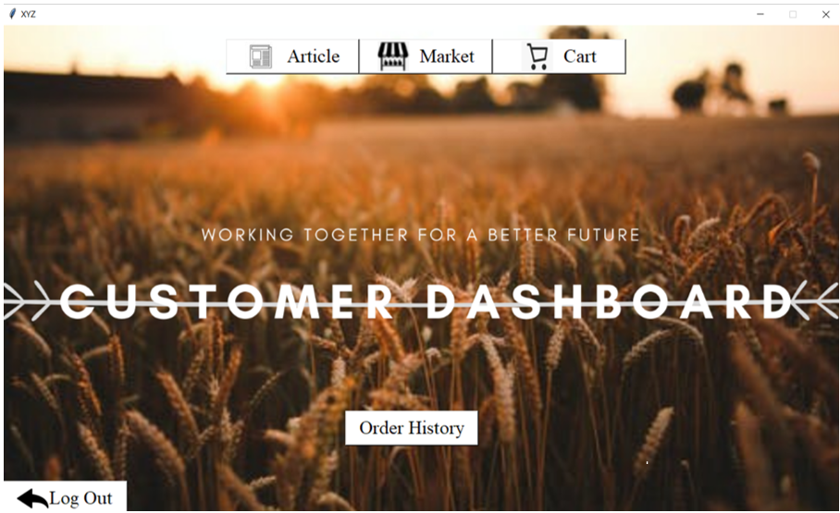

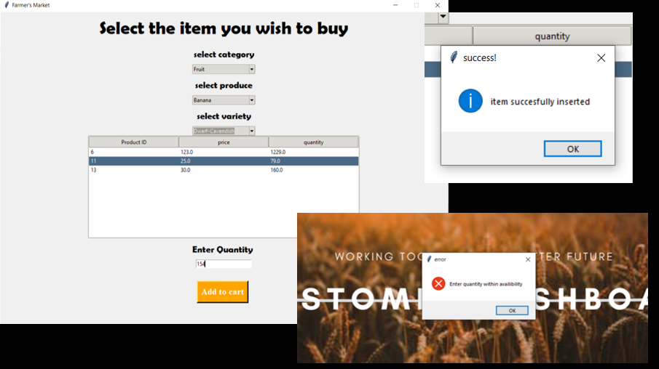

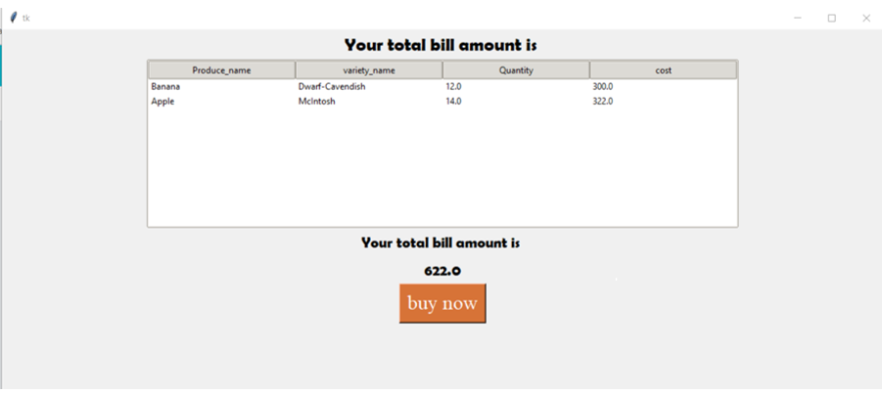

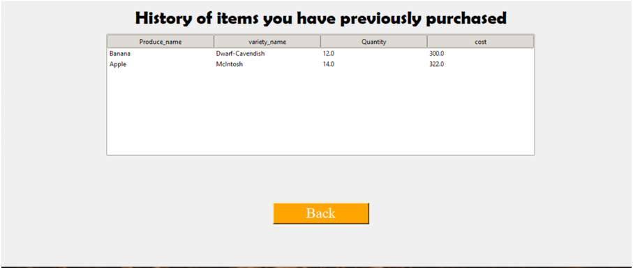

DATABASE

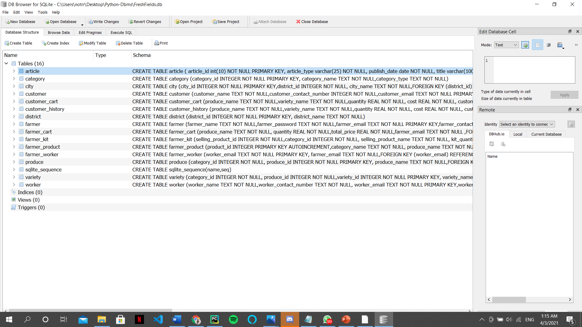

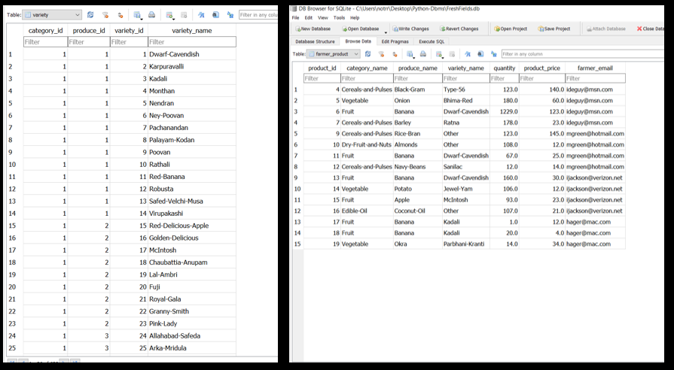

**CONCLUSION AND FUTURE SCOPE**

This Project will thus pave the way for an efficient means to carry out the buying and selling of the products. Farmers will earn money as per the work they have done and will not suffer losses. Also, the system it completely online (webapp/app) thereby reducing the price aspect of the system tremendously. This system is proposed to replace the existing system where the farmer has to suffer between the manufacturers and the traders. Also, the main advantage of this project is that it uses Information Technology. The User only needs basic products like a Computer and an internet connection.

Our application can we converted into an android/ios application thus making it easily accessible to the majority population of India.

There are many ways in which this application could be updated to be more efficient and have a wider scope in the future. Some of them are:

1. Readability of the application as a whole in India could be improved by adding a feature to translate its pages into local languages like Hindi and Marathi.
2. Connectivity across the users on the application could be enhanced by adding modules like Photo Uploading to allow the farmers to display their crops, or a messaging portal where the users could communicate with each other. There could also be Audio/Video calls that would be made available to the users.
3. Transportation, travel and other miscellaneous commodities could be incorporated into the app itself so the users would not need to refer to third-parties for it.
4. In app crop testing and quality check facility can be integrated in the app

**SOCIETAL APPLICATION**

Our application helps to provide the hardworking farmers of our country the business and clients that they need and most of all, deserve. It is free and open-source and easily accessible to even someone who is not technically sound. It helps the wholesalers and retailers in buying produce directly from a large number of farmers. Thereby, it enables the wholesalers and retailers in expanding their business. It features online shopping for fertilizers, pesticides, machinery & tools, etc. It enables farmers to hire laborers, which in turn, will help the farm laborers to find small jobs by having a work profile on the website. As a whole, ‘Fresh Fields’ provides a concept of virtual agricultural trade to its users.